George Meredith (1828-1909)

Place of interest: Ramsgate

In a letter dated October 1884, the poet and novelist George Meredith tells Robert Louis Stevenson of his plan to visit [Ramsgate](/19c/19c-ramsgate), ‘whither I go for bracing air, for half a week’.[1] As holiday reading Meredith intends to take with him the play *_Beau Austin_* by W.E. Henley and Stevenson, which had been sent to Meredith by Stevenson. Most of Meredith’s life was spent in the Surrey countryside which he loved, but visits to the coast were important to him for the health benefits of fresh sea air and bathing. Salt-water he considered to be ‘the next best to mountain air’.[2] There is no record of Meredith’s impression of [Ramsgate](/19c/19c-ramsgate) and passing references only are made to Tunbridge Wells and Hawkhurst. This reticence contrasts with his comments on bathing in the rival Sussex resort of Eastbourne, which is described with Meredith’s characteristic humour as being:

delightful, especially for those who enjoy a sight of bottoms . . . you see half a dozen fat men at a time scampering out of the machines a mile away to hide their middle nakedness posterior. Then they dive, they rise, there is a glistening on the right cheek and the left - too distant to offend the most gingerly. I opine so, for I have beheld antique virgins spyglass in hand towards the roguish spot’.[3]

However the Kentish countryside does feature as one of the settings in Meredith’s novel _*The Amazing Marriage_*. A big house called Esslemont surrounded by ‘quiet country’ is part of the country estate of Lord Fleetwood and is symbolic of his wife’s growing independence in response to his neglect and cruel treatment.[4] Abandoned by her husband on their wedding day Carinthia has lived alone and made a life for herself, arriving in Kent from Wales with the reputation that ‘she’d drive a hole through a robber stopping her on the road, as soon as look at him’.[5] Carinthia ‘soon won a fearful name at Kentish cottage hearths . . . she did all the things that soldiers do’ and resists Lord Fleetwood’s attempts at reconciliation when he visits Esslemont.[6] Telling her husband that she has no right to refuse him entry to his own house Carinthia protects her privacy stating simply ‘I guard my rooms’.[7] _*The Amazing Marriage_* was Meredith’s final completed novel, published in 1895. Carinthia is perceived as representing the New Woman of late nineteenth century literature, although Meredith, always sympathetic to women’s role in society, had been working on this novel since 1879. As the last in a series of increasingly independent women, Carinthia is considered by many critics as Meredith’s most successful heroine. She demonstrates mental fortitude combined with physical strength, using the skills from her childhood in the Alpine mountain-land to adapt to life in England and the unfamiliar surroundings of the Kentish countryside.

Works cited:

*The Letters of George Meredith*, edited by C.L. Cline in three volumes (Oxford, The Clarendon Press, 1970)

George Meredith, _*The Amazing Marriage_* [1895] (London,

Constable & Company Ltd, Mickleham edition,1922)

**Sylvia Hornsby**

Biography

My twenty-year-old self, living in Eastbourne and studying architecture in Brighton, could not have imagined that fifty years later I would be embarking on a course of study for a PhD in Literature at Canterbury Christ Church University. And yet . . . I married a fellow student, worked in Brighton and London, and gained my Diploma in Architecture. We moved to Canterbury, our children arrived, and we started a family business, supplying lace-making equipment to customers in more than seventy countries. When our two daughters had graduated and my husband had begun his third career as a parish priest, I returned to study with The Open University. The certificate for my BA in Literature was the best present I received for my 65th birthday. I discovered George Meredith, little-known Victorian poet and novelist, while researching for my MA on male writers who expressed empathy for women. An interest in the man and his writing has become an obsession and Meredith is the subject of my PhD research which continues to provide intellectual stimulation, and a reason to ignore the housework.

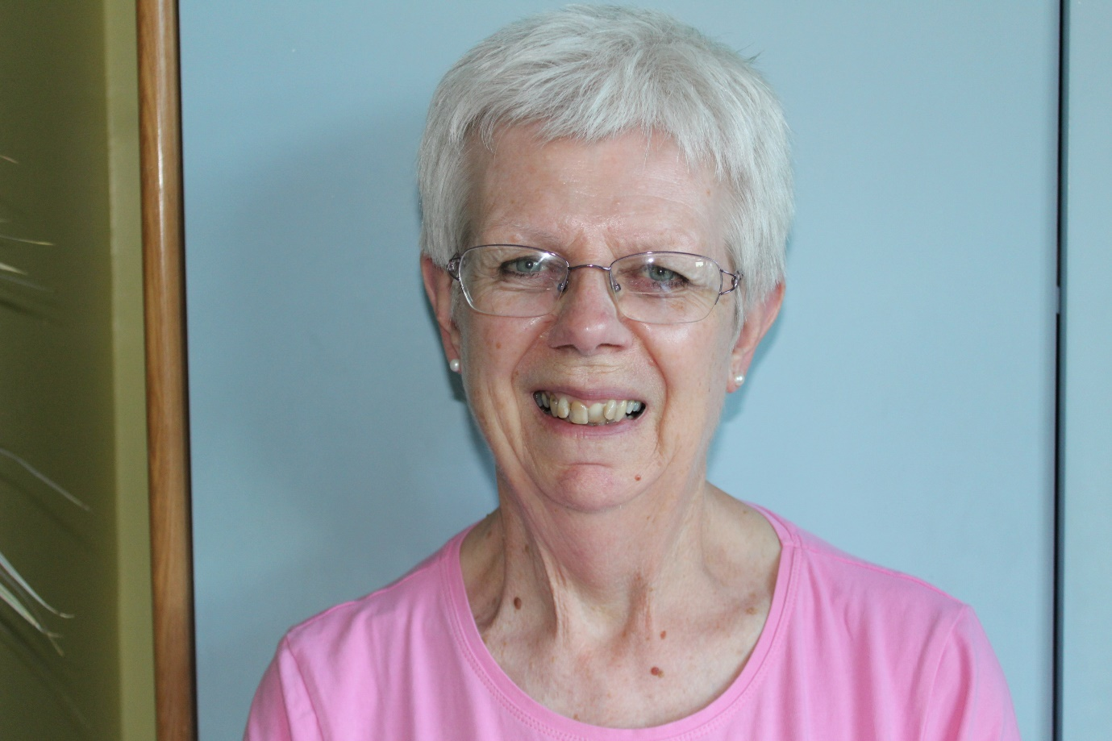

1. Cline vol 2. 747.
2. Cline vol 1. 426.
3. Cline vol 1. 426.
4. XXXVI. 376.
5. XXXIV. 362.
6. XXXIV. 361.
7. XXXVII. 388.